Dr. Oz’s Big January Weight Loss Plan that uses top weight loss research & makes it applicable to the real world. This diet is both psychological & medically sound for lasting results, tailored to individual’s needs.

**"The Day Off Diet”**

THE SELL:

When most of us think about starting a diet we think that means forsaking ALL the fattening foods we love. It means no sweets, no cream sauces, no chips, and no wine! This is often the reason people go crazy eating the night before they start a diet. Anyone of us can follow a restrictive diet for a short time but sooner or later we will crack and binge on the foods we’ve been denying ourselves.

The 6 Day Diet allows you have your cake & eat it too (literally) -- as long as you "cheat" the sensible way, one day a week.

* This is a plan that speaks to ALL people. Whether they need to lose , 5 pounds, 10 pounds, 50 pounds or 100 pounds
* The “Day Off” is there to give this plan more flexibly. We all have days when we are hungrier than other days, or something unexpected comes up and we just can’t stick to our diet or we don’t want to
* Prevents the “All or Nothing” Mentality
* It’s a diet that doesn’t make you a social outcast because YOU PICK YOUR DAY OFF
* We make it impossible for people to fail; there is always a chance to RESET. You fall off, the next day is Day 1.

HOW IT WORKS:

* We provide a Med Vetted 6 Day Meal Plan
* On the 7th Day…we instruct people to have an “off” day. (Not a binge day! Just take a break from strict dieting)

TO GET STARTED

* Take your personal assessment
* Print your starter kit from doctoroz.com (shopping list, calendar, meal builder)
* Map out important events for the month and circle the one day each week you want to make “off Day” (ie: your birthday=off day, thanksgiving=off day)
* Join Support Community
* Track your starting weight

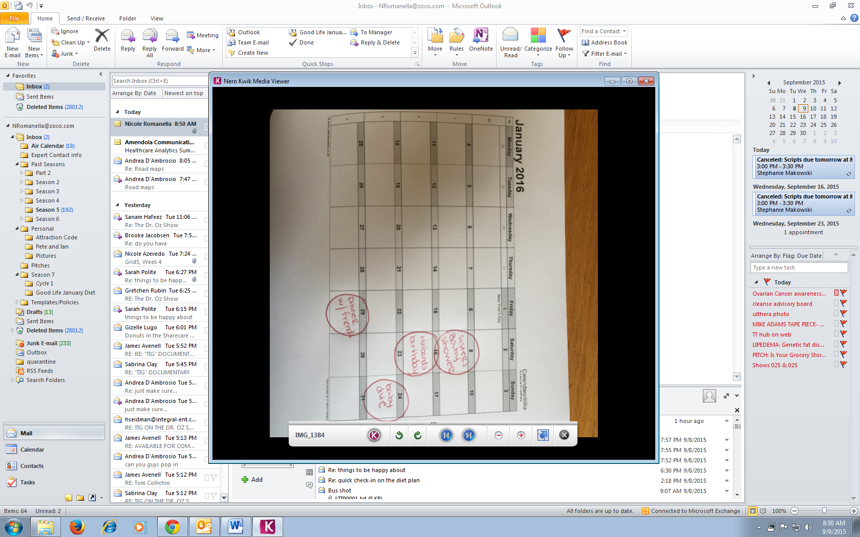 This visual is important because you see an end goal week after week as opposed to holding out on the diet as long as you possible can and then caving when a deadline is simply a number on the scale

HOW IT WORKS (6 Days A Week)

* 3 meals, 2 snacks
* Unlimited Non Starchy Veggies

High Protein Breakfast: CHOOSE TO EAT IT or DRINK IT

**EAT IT:**

* + 1 egg+ 7 ounce 2 % plain Greek yogurt + 1 serving of fruit (pick your favorite)

**DRINK IT**: Peanut Butter Banana Smoothie

* 7 ounces of 2% plain Greek yogurt
* 1 Tbsp. almond butter
* ½ Banana
* 1 tbsp. flaxseeds
* Ice

Lunch & Dinner (use below between two meals to your liking)

* 6 ounces of lean protein (chicken, turkey, fish, eggs OR Tofu)
* 2 servings of complex carbohydrates
* Unlimited non starchy veggies

Example(s):

Lunch: 3 ounces of grilled chicken, 1 medium Sweet Potato & Steamed Asparagus

Dinner: 3 ounces of salmon, ½ C whole grain pasta & steamed cabbage

**2 MUFA SNACKS PER DAY**

* 1 ounce Nuts (Almonds, Brazil Nuts, Cashews, Hazelnuts, Macadamia Nuts, Pecans, Pistachios, Walnuts )
* ¼ Avocado
* 2 TBSP. Nut Butter (Almond, Cashew or Peanut)
* 10 jumbo Olives (Green or Black)
* ¼ C Sunflower Seeds , ¼ C Pumpkin Seeds

**List of Non-starchy Vegetables**

* Artichoke & Artichoke hearts
* Asparagus
* Bamboo shoots
* Bean sprouts
* Beets
* Brussels sprouts
* Broccoli
* Cabbage
* Cauliflower
* Celery
* Cucumber
* Daikon
* Eggplant
* Greens (collard, kale, mustard, turnip, chicory, endive, escarole, lettuce, romaine, spinach, arugula, radicchio, watercress)
* Hearts of palm
* Leeks
* Mushrooms
* Okra
* Onions
* Pea pods
* Peppers
* Radishes
* Rutabaga
* Sprouts
* Sugar snap peas
* Swiss chard
* Tomato
* Turnips
* Water chestnuts
* Zucchini

**Complex Carbohydrates**-

* 1 Cup Legumes (lentils, beans edamame, chick peas)
* 1 Cup Starchy vegetables (Parsnip, Plantain, Sweet Potato, Pumpkin, Squash, Green Peas or Corn)
* ½ C Whole grains - oatmeal, pasta, whole-grain bread, quinoa

**Protein:**

* chicken, fish, eggs, seafood or TOFU
* If vegetarian: lentils, beans, nuts

**ALSO ALLOWED**

* 2 TBSP Heart healthy oil per Day (olive, grapeseed, canola)
* Balsamic Vinegar
* All Spices

**Day 7 (Once a Week) Have an Off Day**

What that means: **Eat what you crave!**